**COLLEGE ADMISSION APPROVAL MANAGEMENT**

**ABSTRACT**

The **College Admission Management System** is a web-based application developed using the **MERN (MongoDB, Express.js, React.js, Node.js) stack** to streamline the student admission process. The system enables students to register, log in securely, and apply for admission by providing personal details and uploading necessary documents. An admin panel allows administrators to review applications, approve or reject submissions, and manage the overall admission process efficiently.

The frontend of the application is built using **React.js** with **Redux** for state management, ensuring a dynamic and responsive user interface. **Tailwind CSS** is used to enhance the design and improve user experience. The backend is developed with **Node.js** and **Express.js**, handling authentication, application logic, and database interactions. **MongoDB** serves as the database, storing user details and application records. **Multer** is used for file uploads, while **bcrypt.js** and **jsonwebtoken (JWT)** ensure secure authentication.

Key features of the system include:

* **Student Authentication**: Secure login and registration using JWT authentication.
* **Application Submission**: Students can submit personal information and required documents.
* **Admin Dashboard**: Administrators can review applications and approve or reject them.
* **Email Notifications**: Students receive updates on their application status via email using **Nodemailer**.
* **Secure File Uploads**: Documents are uploaded and stored securely using **Multer**.

This project aims to eliminate the inefficiencies of traditional paper-based admission processes by providing an automated, user-friendly, and secure system. The application ensures transparency, reduces administrative workload, and enhances the overall admission experience for both students and administrators.

**INTRODUCTION**

In today's digital age, educational institutions are increasingly adopting online systems to streamline administrative processes. One such critical process is student admissions, which traditionally involves a lot of paperwork, manual verification, and communication delays. To address these challenges, this **College Admission Management System** is designed as a **MERN (MongoDB, Express.js, React.js, Node.js) stack** web application that automates and simplifies the admission process.

This system allows students to **register, log in securely, and apply for admission** by submitting personal details and uploading required documents. On the administrative side, authorized personnel can **review applications, approve or reject them**, and notify students of their application status through an integrated email notification system.

**Purpose of the Project**

The primary goal of this project is to **eliminate inefficiencies in the traditional admission process** by providing a **centralized, automated, and user-friendly** platform for both students and administrators. The system ensures:

* **Convenience**: Students can apply from anywhere, anytime, without visiting the college physically.
* **Efficiency**: Reduces paperwork and speeds up the review process for administrators.
* **Security**: Implements secure authentication, data encryption, and document storage mechanisms.
* **Transparency**: Students can track their application status in real time.

**Scope of the Project**

This project focuses on the **admission process** and covers key functionalities such as:

* **User Registration & Authentication**: Secure login system using **JWT (JSON Web Token)** authentication.
* **Student Application Submission**: Form-based data entry with file upload support for documents.
* **Admin Panel for Application Management**: Admins can view, approve, or reject applications.
* **Email Notifications**: Automated email alerts sent to students regarding their application status.
* **Secure File Upload & Storage**: Utilizes **Multer** for handling document uploads.

**Technology Stack Used**

The system is developed using the following technologies:

* **Frontend:** React.js, Redux, React Router, Tailwind CSS, Axios
* **Backend:** Node.js, Express.js, MongoDB, Mongoose
* **Security & Authentication:** Bcrypt.js, JSON Web Token (JWT)
* **File Handling & Emails:** Multer for file uploads, Nodemailer for email notifications

This project demonstrates the **integration of modern web technologies** to create an efficient and scalable admission management system, ensuring a **seamless and secure** experience for students and administrators.

**OBJECTIVES**

The **College Admission Management System** is designed to **automate and enhance** the student admission process by providing a seamless and efficient platform for students and administrators. The key objectives of this project are:

**1. Automate the Admission Process**

* Provide an online system where students can **register, log in, and submit applications** without physical paperwork.
* Reduce manual workload for college administration by digitizing the admission process.

**2. Ensure Secure User Authentication**

* Implement **JWT-based authentication** to ensure secure login and session management for students and administrators.
* Protect user credentials using **bcrypt.js** for password hashing.

**3. Enable Online Application Submission**

* Allow students to fill out an admission form, providing **personal details, academic information, and required documents**.
* Use **Multer** for secure file uploads, ensuring proper storage and retrieval of documents.

**4. Provide an Efficient Admin Panel**

* Enable administrators to **view, review, approve, or reject** student applications.
* Store application statuses securely in the **MongoDB database** for easy tracking.

**5. Implement Email Notifications**

* Use **Nodemailer** to send automated **confirmation and status update emails** to students.
* Ensure timely communication between students and the administration.

**6. Improve System Performance and Scalability**

* Use **React.js with Redux** for efficient state management and a responsive user interface.
* Develop a **scalable backend** using **Node.js and Express.js** to handle multiple user requests.

**7. Enhance User Experience with a Modern UI**

* Design a clean and user-friendly interface using **Tailwind CSS** for better accessibility and responsiveness.
* Ensure a smooth navigation experience with **React Router DOM**.

**8. Maintain Data Security and Integrity**

* Secure user data and applications using proper **validation techniques** from **express-validator**.
* Implement **CORS (Cross-Origin Resource Sharing)** policies to prevent unauthorized access.

By achieving these objectives, the **College Admission Management System** ensures a **fast, secure, and efficient** admission process, reducing administrative burden while improving the student experience.

**EXISTING SYSTEM**

The traditional college admission process is **manual, time-consuming, and inefficient**, involving physical paperwork, in-person visits, and prolonged processing times. This system poses several challenges for both students and administrators.

**1. Manual Application Submission**

* Students must **physically visit** the college to collect, fill out, and submit admission forms.
* The process is inconvenient, especially for students applying from distant locations.

**2. Paper-Based Document Handling**

* Students submit **hard copies** of required documents, leading to storage and management issues.
* Documents can be **lost, damaged, or misplaced**, causing delays in the admission process.

**3. Lengthy and Inefficient Verification Process**

* The admission committee must manually **verify student details and documents**, increasing processing time.
* Errors in document verification can lead to delays or incorrect admissions.

**4. Lack of Online Tracking and Notifications**

* Students do not receive **real-time updates** on their application status.
* Any communication (such as acceptance or rejection) is done through **manual phone calls or emails**, which is inefficient.

**5. Administrative Overload**

* Staff members handle multiple applications manually, leading to **increased workload** and a higher chance of **human errors**.
* Sorting and organizing applications manually is **time-consuming and unorganized**.

**6. Security and Data Management Issues**

* Paper-based records are vulnerable to **damage, unauthorized access, or misplacement**.
* No proper mechanism exists to securely store and retrieve student information.

**PROPOSED SYSTEM**

To overcome the challenges of the existing manual admission system, the **College Admission Management System** is proposed as a **web-based MERN (MongoDB, Express.js, React.js, Node.js) application** that automates and streamlines the admission process. This system enhances efficiency, security, and user experience by enabling students to apply online and administrators to manage applications seamlessly.

**Key Features of the Proposed System**

**1. Online Registration & Secure Authentication**

* Students can **register and log in** securely using **JWT-based authentication**.
* Passwords are securely hashed using **bcrypt.js** to prevent unauthorized access.

**2. Digital Admission Form Submission**

* Students can fill out and submit an admission form online, providing **personal details, academic records, and required documents**.
* **Multer** is used for **secure document uploads**, eliminating the need for physical paperwork.

**3. Automated Application Processing**

* The system automatically **stores and organizes** student applications in **MongoDB**, reducing manual workload.
* Data validation using **express-validator** ensures accurate and complete information.

**4. Admin Dashboard for Application Management**

* Administrators can **view, verify, approve, or reject** applications in an interactive dashboard.
* Each application’s status is updated dynamically in real time.

**5. Real-Time Application Status Tracking**

* Students can **track their application status** (Pending, Approved, or Rejected) through their dashboard.
* Eliminates the need for students to visit the college physically for updates.

**6. Automated Email Notifications**

* The system uses **Nodemailer** to send **real-time email updates** about application status (confirmation, approval, or rejection).
* Improves communication efficiency between students and administrators.

**7. User-Friendly Interface with Modern UI/UX**

* **React.js with Redux** provides a smooth and dynamic user experience.
* **Tailwind CSS** ensures a clean, responsive, and visually appealing design.

**8. Secure Data Management & Access Control**

* Uses **MongoDB** as a secure database for storing student and admin records.
* Implements **CORS policies** and role-based access control to prevent unauthorized data access.

**Benefits of the Proposed System**

✅ Eliminates paperwork and provides an entirely digital admission process.

✅ Reduces manual errors and speeds up the application review process.

✅ Enhances security with JWT authentication, encrypted passwords, and access control.

✅ Saves time and effort for both students and administrators.

✅ Ensures transparency by allowing students to track their application status online.

**Conclusion**

The proposed College Admission Management System offers a modern, efficient, and automated solution to traditional admission challenges. By leveraging the MERN stack, this system provides a secure, scalable, and user-friendly platform that improves the admission experience for both students and administrators.

**MODULE DESCRIPTION**

The **College Admission Management System** consists of several interconnected modules that work together to provide a seamless and efficient admission process. Each module is responsible for specific functionalities within the system. Below is a detailed description of each module:

**1. User Authentication Module**

**Purpose:**

This module handles **student and admin authentication**, ensuring secure access to the system.

**Functionalities:**

✅ User registration (students) with email and password.  
✅ Secure login using **JWT authentication**.  
✅ Password encryption using **bcrypt.js**.  
✅ Role-based authentication (Student/Admin).  
✅ Logout functionality to clear sessions.

**Technologies Used:**

🔹 **Frontend:** React.js, Redux, React Router, Axios  
🔹 **Backend:** Node.js, Express.js, JSON Web Token (JWT), bcrypt.js  
🔹 **Database:** MongoDB (User collection)

**2. Student Application Module**

**Purpose:**

Allows students to **fill out and submit** their admission application with required details and documents.

**Functionalities:**

✅ Form submission with fields such as **name, email, academic details, and course selection**.  
✅ **Multer-based file upload** for submitting necessary documents.  
✅ Data validation using **express-validator** to ensure completeness and accuracy.  
✅ Application status tracking (Pending, Approved, Rejected).

**Technologies Used:**

🔹 **Frontend:** React.js, Redux, Axios, Tailwind CSS  
🔹 **Backend:** Node.js, Express.js, Multer, express-validator  
🔹 **Database:** MongoDB (Application collection)

**3. Admin Dashboard Module**

**Purpose:**

Allows **administrators to manage student applications** efficiently.

**Functionalities:**

✅ View the list of **all submitted applications**.  
✅ Review student details and uploaded documents.  
✅ Approve or reject applications with a single click.  
✅ Update application status in real time.  
✅ Provide feedback/comments on application status.

**Technologies Used:**

🔹 **Frontend:** React.js, Redux, Tailwind CSS  
🔹 **Backend:** Node.js, Express.js, MongoDB  
🔹 **Database:** MongoDB (Application collection)

**4. Notification & Email Module**

**Purpose:**

This module ensures **students receive real-time notifications** about their application status.

**Functionalities:**

✅ Sends **confirmation emails** upon application submission.  
✅ Notifies students via email when their application is **approved or rejected**.  
✅ Uses **Nodemailer** for sending emails.

**Technologies Used:**

🔹 **Backend:** Node.js, Express.js, Nodemailer  
🔹 **Database:** MongoDB (User & Application collections)

**5. File Upload & Storage Module**

**Purpose:**

Handles **secure document uploads** during the application process.

**Functionalities:**

✅ Allows students to **upload required documents** in various formats (PDF, JPEG, PNG).  
✅ Uses **Multer** to handle file uploads.  
✅ Ensures documents are securely stored and accessible by admins only.

**Technologies Used:**

🔹 **Backend:** Node.js, Express.js, Multer  
🔹 **Database:** MongoDB (Stores file references)

**6. User Dashboard Module**

**Purpose:**

Provides an interactive **dashboard for students** to track application status.

**Functionalities:**

✅ Displays the **current status** of submitted applications.  
✅ Allows students to **edit/update their profile** if required.  
✅ Provides access to uploaded documents.

**Technologies Used:**

🔹 **Frontend:** React.js, Redux, Tailwind CSS  
🔹 **Backend:** Node.js, Express.js, MongoDB

**SYSTEM REQUIREMENTS**

**1. Hardware Requirements**

**Minimum Requirements:**

✔ **Processor:** Intel Core i3 (or equivalent)  
✔ **RAM:** 4 GB  
✔ **Storage:** 50 GB free space (HDD/SSD)  
✔ **Internet Connection:** Broadband (2 Mbps)  
✔ **Display:** 1366 × 768 resolution  
✔ **Graphics:** Integrated Graphics

**Recommended Requirements:**

✔ **Processor:** Intel Core i5/i7 (or higher)  
✔ **RAM:** 8 GB or higher  
✔ **Storage:** 100 GB SSD (for better performance)  
✔ **Internet Connection:** High-speed broadband (10+ Mbps)  
✔ **Display:** Full HD (1920 × 1080) or higher  
✔ **Graphics:** Dedicated GPU (NVIDIA/AMD) for faster rendering

**2. Software Requirements**

**Operating System:**

✔ Windows 10/11, macOS, or Linux (Ubuntu 20.04+)

**Frontend Technologies:**

✔ React.js – UI framework  
✔ Redux – State management  
✔ Tailwind CSS – Styling  
✔ React Router DOM – Navigation  
✔ Axios – API requests

**Backend Technologies:**

✔ Node.js (v18+) – JavaScript runtime  
✔ Express.js – Backend framework  
✔ MongoDB (v5.0+) – NoSQL database  
✔ Mongoose – Database modeling  
✔ JWT (jsonwebtoken) – Authentication  
✔ bcrypt.js – Password hashing  
✔ Multer – File uploads  
✔ Nodemailer – Email notifications

**Development Tools:**

✔ VS Code / WebStorm – Code editor  
✔ Postman – API testing  
✔ MongoDB Compass – GUI for database management  
✔ Git & GitHub – Version control  
✔ Vite – React app bundler

**Server Deployment:**

✔ Node.js & PM2 – Process manager for Node.js applications  
✔ MongoDB Atlas – Cloud database (optional)

**SOFTWARE DESCRIPTION**

**REACT**

**What is React?**

✔ React is a **JavaScript library** for building dynamic and interactive **user interfaces (UI)**, primarily for **single-page applications (SPA)**.  
✔ It was developed and maintained by **Meta (formerly Facebook)**.  
✔ React follows a **component-based architecture**, making UI development more **modular, reusable, and scalable**.

**Key Features of React**

**1. Component-Based Architecture**

* React applications are built using **components**, which are reusable, self-contained UI elements.
* Components can be **functional** or **class-based**, with functional components being preferred in modern React development.

**2. Virtual DOM (Document Object Model)**

* React uses a **Virtual DOM** to efficiently update and render changes without reloading the entire page.
* When a change occurs, React updates only the **necessary parts** of the actual DOM, improving **performance and speed**.

**3. JSX (JavaScript XML)**

* React uses **JSX**, which allows developers to write **HTML-like syntax inside JavaScript**.
* JSX makes it easier to create and visualize UI components.

**4. State Management**

* React manages component-specific data using **state**.
* State updates trigger re-renders, ensuring that the UI stays **synchronized** with data.

**5. Props (Properties)**

* Props are **used to pass data** between components, enabling **reusability and modularization**.

**6. React Hooks**

* Hooks (like useState, useEffect, etc.) allow developers to **manage state and lifecycle methods** in functional components.
* The **useEffect hook** replaces lifecycle methods like componentDidMount in class components.

**7. React Router**

* React Router enables **navigation** between different views/pages in a React application **without refreshing the browser**.

**8. Redux for State Management**

* Redux is often used with React to **manage complex application-wide states** efficiently.
* It provides a **centralized store**, allowing multiple components to access and update shared data.

**Advantages of React**

✅ **Fast & Efficient** – The Virtual DOM optimizes rendering, improving app performance.  
✅ **Reusable Components** – Makes development faster and maintenance easier.  
✅ **Easy to Learn & Use** – Uses JavaScript and JSX, making it developer-friendly.  
✅ **Strong Community Support** – Large developer community and extensive documentation.  
✅ **SEO-Friendly** – Supports **server-side rendering (SSR)** with frameworks like Next.js.  
✅ **Flexible & Scalable** – Can be integrated with various **backend technologies** and libraries.

**Use of React in This Project**

* **Building the User Interface** – React is used to design and render the **student dashboard, admin panel, and application forms**.
* **State Management** – Redux manages **user authentication, application data, and UI states**.
* **Routing** – React Router helps in navigation between different sections, such as **login, application form, and dashboard**.
* **API Integration** – Axios is used with React to **fetch and send data** to the backend.

**Conclusion**

React is a **powerful, flexible, and efficient** JavaScript library for building modern **web applications**. Its **component-based approach, Virtual DOM, and state management capabilities** make it an ideal choice for the **College Admission Management System**, ensuring a **smooth, responsive, and user-friendly experience**.

**NODE.JS**

**What is Node.js?**

✔ **Node.js** is an **open-source, cross-platform JavaScript runtime environment** that allows developers to run JavaScript code outside of a web browser.  
✔ It is built on **Google Chrome’s V8 JavaScript engine**, making it **fast and efficient**.  
✔ Node.js is mainly used for **building scalable, server-side applications**, such as **APIs, web servers, and real-time applications**.

**Key Features of Node.js**

**1. Asynchronous & Non-Blocking I/O**

* Node.js follows an **event-driven, non-blocking** architecture, which means it can handle multiple requests simultaneously **without waiting for one to complete**.
* This makes it **highly efficient and scalable** for applications that require fast data processing.

**2. Single-Threaded but Highly Scalable**

* Node.js operates on a **single-threaded event loop**, which efficiently handles thousands of connections simultaneously using **callbacks and promises**.

**3. Cross-Platform Compatibility**

* Node.js runs on **Windows, macOS, Linux**, and even cloud platforms like **AWS, Azure, and Google Cloud**.

**4. Built-in Package Manager (NPM)**

* **Node Package Manager (NPM)** provides access to **over a million reusable packages**, making development faster and more efficient.
* Examples: express (for backend framework), mongoose (for MongoDB), jsonwebtoken (for authentication).

**5. Real-Time Applications**

* Ideal for **real-time applications** like **chat apps, live notifications, and online gaming**, thanks to its **WebSockets and event-driven nature**.

**6. RESTful API Development**

* Node.js is commonly used to build **REST APIs**, enabling seamless communication between **frontend (React.js) and backend (Node.js + Express.js)**.

**7. File Handling & Streaming**

* Supports **file system operations**, allowing developers to handle file uploads, process large files, and stream data efficiently.

**Advantages of Node.js**

✅ **Fast Execution** – Uses **V8 JavaScript engine**, making it extremely fast.  
✅ **Scalability** – Can handle **high-concurrent** requests without performance loss.  
✅ **Lightweight** – Uses **event-driven architecture**, reducing resource consumption.  
✅ **Full-Stack JavaScript** – Enables **JavaScript development on both frontend (React.js) and backend (Node.js)**.  
✅ **Large Community Support** – Thousands of developers contribute to its growth and provide extensive resources.

**Use of Node.js in This Project**

🔹 **Backend Server:**

* Handles **HTTP requests/responses** using **Express.js**.
* Manages **user authentication (JWT-based login/logout).**
* Processes **form submissions and document uploads** (using Multer).

🔹 **Database Interaction:**

* Uses **Mongoose** to connect and interact with **MongoDB**.
* Handles **student data, application records, and admin approvals**.

🔹 **Authentication & Security:**

* Implements **JWT (JSON Web Token) for secure authentication**.
* Encrypts passwords using **bcrypt.js**.

🔹 **Email Notifications:**

* Sends real-time **email updates** to students about their application status using **Nodemailer**.

🔹 **File Handling:**

* Manages **file uploads for student documents** using **Multer**.

**Conclusion**

Node.js is a **powerful, lightweight, and highly scalable** runtime for building **modern web applications**. In this project, **Node.js with Express.js** plays a crucial role in **managing user authentication, handling database operations, and providing a secure and efficient backend system** for the **College Admission Management System**.

**EXPRESS**

**What is Express.js?**

✔ **Express.js** is a **fast, minimal, and flexible web framework** for **Node.js**.  
✔ It is primarily used to **build web applications and APIs** efficiently.  
✔ Express simplifies server-side development by providing **built-in HTTP methods, middleware support, and routing capabilities**.

**Key Features of Express.js**

**1. Lightweight and Fast**

* Express is a **minimalistic framework**, making it **fast and efficient** for backend development.
* It provides essential features without adding unnecessary complexity.

**2. Middleware Support**

* Express uses **middleware functions** to handle **request and response processing** at various stages.
* Middleware is used for **parsing JSON data, handling authentication, enabling CORS, and error handling**.

**3. Routing System**

* Express provides a **powerful routing mechanism** to handle various **HTTP methods** (GET, POST, PUT, DELETE).
* It allows defining multiple endpoints for handling different functionalities in a web application.

**4. RESTful API Development**

* Express makes it easy to **develop RESTful APIs**, which are essential for **frontend-backend communication**.
* It supports **JSON-based responses**, making it ideal for integrating with **React.js applications**.

**5. Integration with Databases**

* Express can connect to various databases such as **MongoDB (using Mongoose), MySQL, and PostgreSQL**.
* It enables efficient **data storage, retrieval, and management** in backend applications.

**6. Error Handling**

* Express provides a built-in mechanism for **error handling**, making debugging and maintenance easier.
* Custom error-handling middleware can be implemented to manage application errors effectively.

**7. Security Features**

* Supports authentication methods such as **JWT (JSON Web Token)** for secure user login and session management.
* Helps prevent security threats like **SQL injection, Cross-Site Scripting (XSS), and Cross-Site Request Forgery (CSRF)**.

**Advantages of Express.js**

✅ **Fast and Efficient** – Minimalistic framework with **low resource consumption**.  
✅ **Easy to Learn and Use** – Uses simple **JavaScript syntax** for development.  
✅ **Highly Scalable** – Can handle **large-scale applications** and concurrent users.  
✅ **Large Community Support** – Backed by an extensive **developer community**.  
✅ **Flexible Middleware System** – Allows efficient **request handling and processing**.

**Use of Express.js in This Project**

✔ **Handles API Requests:** Acts as the **backend server**, processing API requests from the **React frontend**.  
✔ **Manages Authentication:** Implements **JWT-based authentication** for user login and access control.  
✔ **Processes Student Applications:** Handles **application submission, document uploads, and admin approvals**.  
✔ **Enables Database Communication:** Uses **Mongoose** to store and retrieve **student and application data** from **MongoDB**.  
✔ **Implements Middleware:** Supports **JSON parsing, CORS handling, and error management** for smooth API operations.

**Conclusion**

Express.js is a **powerful, lightweight, and flexible** backend framework that simplifies **web application development**. It plays a crucial role in the **College Admission Management System** by providing an **efficient API backend, handling authentication, processing student applications, and ensuring secure communication with the database**.

**MONGO DB**

**What is MongoDB?**

✔ **MongoDB** is a **NoSQL, document-oriented database** that stores data in **JSON-like BSON format**.  
✔ It is designed for **scalability, flexibility, and high performance**, making it ideal for **modern web applications**.  
✔ Unlike relational databases (MySQL, PostgreSQL), MongoDB does **not use tables, rows, or fixed schemas**. Instead, it uses **collections and documents** to store data.

**Key Features of MongoDB**

**1. NoSQL (Schema-less Structure)**

* Unlike traditional SQL databases, MongoDB **does not require a fixed schema**.
* Data is stored in **collections (equivalent to tables) as documents (equivalent to rows)**, which can have **different structures** within the same collection.

**2. Document-Oriented Storage**

* Data is stored in **JSON-like BSON (Binary JSON) format**, allowing **nested fields** and flexible data structures.
* Example: A student's application can include **personal details, uploaded documents, and admission status** within a single document.

**3. High Scalability & Performance**

* MongoDB supports **horizontal scaling** using **sharding**, allowing it to handle **large amounts of data efficiently**.
* It is optimized for **high-speed read/write operations**, making it ideal for real-time applications.

**4. Flexible Querying**

* Supports powerful **CRUD (Create, Read, Update, Delete) operations** using a simple and expressive query language.
* Queries can be based on **field values, ranges, and regular expressions**.

**5. Indexing for Faster Queries**

* MongoDB uses **indexes** to speed up data retrieval, improving overall performance.

**6. Aggregation Framework**

* Provides advanced **data processing and analytics** through aggregation pipelines, which allow operations like **filtering, grouping, and sorting**.

**7. Replication & High Availability**

* Supports **replica sets**, where multiple database instances store the same data for **backup and failover support**.

**8. Integration with JavaScript & Node.js**

* Since MongoDB uses **JavaScript-based queries**, it integrates seamlessly with **Node.js & Express.js** applications.
* The **Mongoose library** is often used to define schemas and interact with MongoDB in Node.js applications.

**Advantages of MongoDB**

✅ **Flexible Schema** – Allows storing structured and unstructured data in a single collection.  
✅ **High Performance** – Faster read/write operations compared to traditional SQL databases.  
✅ **Easy Scalability** – Supports **horizontal scaling** for handling large datasets.  
✅ **Strong Integration with Node.js** – Works well with **JavaScript-based applications** like **MERN stack**.  
✅ **Replication & Backup** – Ensures data redundancy and high availability.

**Use of MongoDB in This Project**

✔ **Stores Student and Admin Data** – Manages student details, submitted applications, and admin decisions.  
✔ **Handles File Metadata** – Stores document references for uploaded student files (like certificates and ID proofs).  
✔ **Manages Authentication** – Stores hashed passwords and user sessions securely.  
✔ **Supports Real-time Updates** – Allows students to track their admission status dynamically.  
✔ **Seamless API Integration** – Works with **Express.js backend** to fetch and update data efficiently.

**Conclusion**

MongoDB is a **powerful, scalable, and flexible** NoSQL database that plays a critical role in the **College Admission Management System**. Its **document-oriented structure, high-speed querying, and seamless integration with Node.js** make it an ideal choice for handling **student applications, authentication, and file storage** efficiently.

**OTHER 3RD PARTY PACKAGES**

**Frontend Modules (React.js)**

**1. @tailwindcss/vite**

✔ A **Vite plugin for Tailwind CSS** that optimizes the **development and build process**.  
✔ Speeds up the integration of **Tailwind CSS with React.js**, ensuring **fast hot-reloading and optimized styling**.

**2. Axios**

✔ A **promise-based HTTP client** for making API requests from the frontend to the backend.  
✔ Used to **fetch and send data** between React.js and Express.js, such as **user authentication and application submission**.

**3. React**

✔ A **JavaScript library** for building user interfaces, particularly **single-page applications (SPAs)**.  
✔ Provides **component-based architecture**, making UI development **modular and reusable**.

**4. React-DOM**

✔ The **React package for rendering UI components into the browser’s DOM**.  
✔ Ensures smooth **updates and re-renders** in the virtual DOM for optimized performance.

**5. React-Redux**

✔ A library that integrates **Redux (state management)** with **React.js applications**.  
✔ Helps manage **global application state**, such as user authentication and form data, efficiently.

**6. React-Router-Dom**

✔ Handles **client-side routing** in a React application.  
✔ Enables navigation between pages such as **Login, Registration, Application Form, and Admin Dashboard** without reloading the page.

**7. Redux**

✔ A **state management library** that centralizes application state.  
✔ Used to store and manage data like **logged-in user details and application form inputs**.

**8. Redux-Thunk**

✔ A **middleware for Redux** that allows handling **asynchronous API calls**.  
✔ Helps in managing **user authentication, fetching application status, and handling admin actions** asynchronously.

**9. Tailwind CSS**

✔ A **utility-first CSS framework** for styling the frontend efficiently.  
✔ Provides **pre-defined classes** for quick styling without writing custom CSS, ensuring a **responsive and modern UI**.

**Backend Modules (Node.js + Express.js)**

**1. bcryptjs**

✔ A **password-hashing library** used for securing user passwords before storing them in the database.  
✔ Ensures that passwords are stored in an **encrypted format**, protecting against security threats.

**2. cors**

✔ Middleware that enables **Cross-Origin Resource Sharing (CORS)**.  
✔ Allows the **React frontend (running on one port) to communicate with the Express backend (running on another port)** without security restrictions.

**3. dotenv**

✔ A module for **loading environment variables** from a .env file.  
✔ Used to **store sensitive information** like **database connection URLs, JWT secret keys, and email credentials** securely.

**4. Express**

✔ A **lightweight Node.js framework** used to build the backend server and APIs.  
✔ Handles **routes, middleware, authentication, and request processing** efficiently.

**5. Express-Validator**

✔ Middleware for **validating and sanitizing user input** before processing it.  
✔ Ensures that **registration forms, login credentials, and application details** meet the required criteria before storing them in the database.

**6. jsonwebtoken (JWT)**

✔ A library used for **user authentication** by generating **secure tokens (JWTs)**.  
✔ Allows **students and admins to log in securely** and access protected routes.

**7. Mongoose**

✔ A **MongoDB object modeling (ODM) library** for Node.js.  
✔ Simplifies **database interactions**, allowing structured data storage and validation in MongoDB.

**8. Multer**

✔ Middleware for **handling file uploads**, such as **student documents, ID proofs, and certificates**.  
✔ Stores uploaded files efficiently in a specified **storage directory** or cloud storage.

**9. Nodemailer**

✔ A module used for **sending emails** from the backend.  
✔ Used for **sending application confirmation, admin approval/rejection notifications, and password reset emails**.

**10. Nodemon**

✔ A development tool that **automatically restarts the Node.js server** whenever file changes are detected.  
✔ Enhances **developer productivity** by avoiding manual server restarts.

**SYSTEM DESIGN**

The **Input and Output Design** plays a crucial role in ensuring a smooth user experience in the **College Admission Management System**. This section describes the **various inputs provided by users and the corresponding outputs displayed**.

**1. Input Design**

Input design focuses on how **data is entered into the system** efficiently, accurately, and securely.

**Types of Inputs in the System:**

**(A) Student Inputs**

1. **User Registration:**
   * Input: Full Name, Email, Password, Contact Number.
   * Validation: Email format check, password strength validation.
   * Purpose: Creates a new student account.
2. **User Login:**
   * Input: Email, Password.
   * Validation: Ensures correct credentials using **JWT authentication**.
   * Purpose: Allows students to log in to their dashboard.
3. **Application Form Submission:**
   * Input:
     + **Personal Details:** Name, Date of Birth, Gender, Address.
     + **Educational Details:** Previous school/college, Marks obtained, Course applied for.
     + **Document Uploads:** Identity proof, academic certificates (handled via **Multer**).
   * Validation: Ensures all required fields are filled and valid file formats are uploaded.
   * Purpose: Submits the student’s admission application.
4. **Check Application Status:**
   * Input: Student ID or Email (automatically retrieved from logged-in session).
   * Purpose: Fetches the **current status** of the application (**Pending, Approved, Rejected**).

**(B) Admin Inputs**

1. **Admin Login:**
   * Input: Email, Password.
   * Validation: Only authorized admins can access the dashboard.
   * Purpose: Allows administrators to manage student applications.
2. **View Student Applications:**
   * Input: None (Admin fetches applications from the database).
   * Purpose: Displays a list of **submitted applications** with student details and uploaded documents.
3. **Approve/Reject Applications:**
   * Input: **Application ID**, Admin Decision (**Approve/Reject**), and optional remarks.
   * Purpose: Updates the **admission status** in the database and sends an email notification.

**2. Output Design**

Output design focuses on how **data is presented to users in a clear and structured manner**.

**(A) Student Outputs**

1. **Registration Confirmation:**
   * Output: **Success message** or **error notification** if registration fails.
   * Example: "Registration Successful! Please log in."
2. **Login Response:**
   * Output: **Dashboard access** on successful login, or "Invalid email or password" message on failure.
3. **Application Submission Response:**
   * Output: **Application ID and confirmation message** after successful submission.
   * Example: "Your application has been submitted successfully. Application ID: 12345"
4. **Application Status Display:**
   * Output: Shows **status of the application** (Pending, Approved, Rejected).
   * Example:
     + "Your application is under review."
     + "Congratulations! Your application has been approved."
     + "Sorry, your application has been rejected. Please contact the admin for details."

**(B) Admin Outputs**

1. **Dashboard Overview:**
   * Output: List of all student applications with **search and filter options**.
2. **Application Details View:**
   * Output: Displays **full student details, uploaded documents, and status**.
3. **Application Approval/Rejection Confirmation:**
   * Output: "Application Approved Successfully" or "Application Rejected Successfully", along with email notifications sent to the student.

**DATAFLOW DIAGRAM**

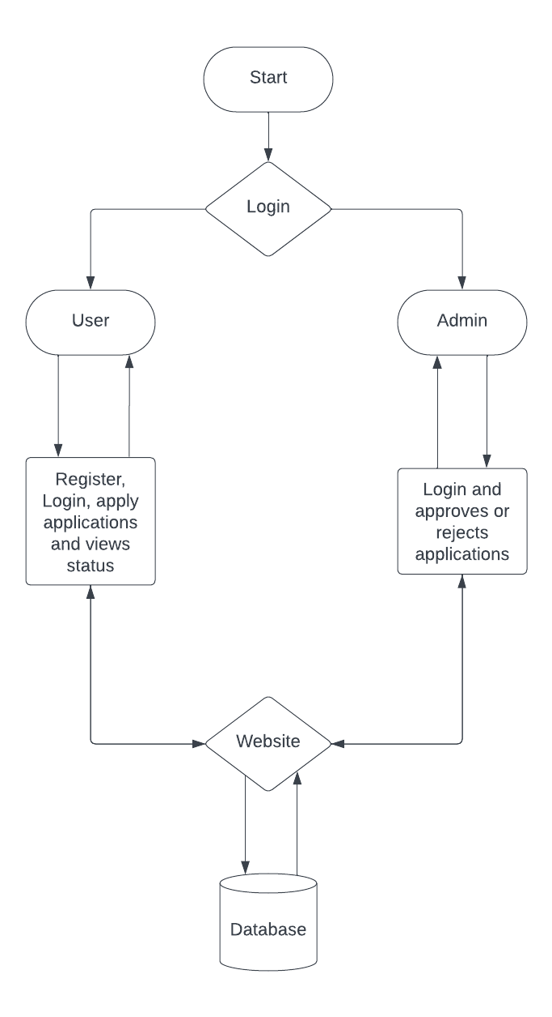

**SYSTEM TESTING**

System Testing is a crucial phase in the **College Admission Management System**, ensuring that all components work together as expected. It involves various levels of testing to validate **functionality, performance, security, and user experience**.

**Types of System Testing Performed**

**1. Unit Testing**

✔ **Objective:** To test individual components (functions, APIs, UI elements) to ensure they work correctly in isolation.  
✔ **Tools Used:** Jest (for React components), Mocha/Chai (for backend APIs).  
✔ **Examples:**

* Testing the **user registration function** to ensure validation errors trigger correctly.
* Testing the **backend API for login authentication** to verify correct JWT token generation.

**2. Integration Testing**

✔ **Objective:** To check if different modules **work together correctly** (e.g., React frontend communicating with Express backend).  
✔ **Tools Used:** Postman (for API testing), Jest.  
✔ **Examples:**

* Testing **form submission** to ensure it successfully stores data in MongoDB.
* Testing if an **admin approval action** updates the student’s application status correctly.

**3. Functional Testing**

✔ **Objective:** To verify that all system functionalities meet **business requirements**.  
✔ **Tools Used:** Manual testing & Selenium (for automated UI testing).  
✔ **Examples:**

* **User Registration:** Checking if users can register and receive confirmation messages.
* **Login & Authentication:** Ensuring only **valid credentials** allow access.
* **Application Submission:** Verifying correct form validation, file uploads, and database storage.
* **Admin Actions:** Testing **application approval/rejection** and email notifications.

**4. User Interface (UI) Testing**

✔ **Objective:** To ensure that the **UI elements, responsiveness, and design consistency** are correct.  
✔ **Tools Used:** Manual testing, Browser DevTools, Cypress.  
✔ **Examples:**

* Checking **mobile responsiveness** on different screen sizes.
* Verifying **button clicks, input fields, and error messages**.
* Ensuring that the **Tailwind CSS styling is applied correctly**.

**5. Performance Testing**

✔ **Objective:** To evaluate the **speed, responsiveness, and scalability** of the system under load.  
✔ **Tools Used:** JMeter, Lighthouse.  
✔ **Examples:**

* Testing how the system handles **multiple concurrent student registrations**.
* Checking the **API response time** for fetching large datasets.

**6. Security Testing**

✔ **Objective:** To identify **vulnerabilities** and ensure **data protection**.  
✔ **Tools Used:** OWASP ZAP, Postman.  
✔ **Examples:**

* Testing **JWT token security** to prevent unauthorized access.
* Checking for **SQL Injection, XSS (Cross-Site Scripting), and CSRF attacks**.
* Ensuring that **passwords are securely hashed using bcrypt**.

**7. User Acceptance Testing (UAT)**

✔ **Objective:** To confirm that the system meets **end-user expectations** before deployment.  
✔ **Process:**

* Selected **students and admins** test the system and provide feedback.
* Any **usability issues or missing features** are identified and resolved.

**Conclusion**

System testing ensures that the **College Admission Management System** functions as expected, is **secure, scalable, and user-friendly**. Various testing techniques, from **unit testing to security testing**, help improve system reliability before deployment.

**CONCLUSION**

The **College Admission Management System** is a robust, secure, and efficient platform designed to streamline the admission process for both students and administrators. By leveraging the **MERN stack (MongoDB, Express.js, React.js, Node.js)**, the system provides a seamless **registration, application submission, and approval workflow**.

The implementation of **secure authentication, document uploads, and real-time status tracking** ensures an enhanced user experience. Features such as **email notifications, role-based access control, and responsive UI** contribute to the system’s reliability and ease of use.

Through **comprehensive system testing**, the platform has been optimized for **functionality, performance, security, and usability**. The successful integration of **frontend and backend modules** ensures smooth communication between students and administrators, making the admission process more efficient.

**Key Takeaways:**

✔ **Simplifies admission processing**, reducing manual paperwork.  
✔ **Ensures secure authentication** using JWT and bcrypt.  
✔ **Provides real-time updates** on application status.  
✔ **Enhances system reliability** through rigorous testing.  
✔ **Optimized UI** for a seamless user experience.

**Future Enhancements:**

🚀 **AI-powered applicant ranking** based on merit.  
🚀 **Integration with payment gateways** for admission fees.  
🚀 **Automated document verification** using OCR technology.

The project successfully meets its objectives, offering a **digital, efficient, and scalable solution** for college admissions.

**FUTURE SCOPE**

The **College Admission Management System** has been designed to automate and streamline the admission process efficiently. However, there are several **enhancements and advancements** that can be incorporated in the future to improve the system's functionality, scalability, and user experience.

**1. AI-Powered Applicant Ranking System**

✔ **Implementation of AI/ML algorithms** to analyze student applications based on academic performance, extracurricular activities, and other criteria.  
✔ Helps in **automated merit-based ranking** and shortlisting of candidates.

**2. Online Fee Payment Integration**

✔ Integration with **payment gateways (PayPal, Stripe, Razorpay, etc.)** to allow students to pay admission fees online.  
✔ Generates **automated receipts** and tracks transaction history.

**3. Automated Document Verification using OCR**

✔ Use **Optical Character Recognition (OCR)** to scan and verify uploaded documents.  
✔ Ensures **authenticity of certificates and IDs** without manual verification.

**4. Chatbot Assistance for Queries**

✔ Integration of an **AI-powered chatbot** to assist students with admission-related queries.  
✔ Provides **24/7 support** for FAQs, deadlines, and document requirements.

**5. Multi-Language Support**

✔ Implementation of **multiple language options** to cater to students from different linguistic backgrounds.  
✔ Enhances **accessibility** for international applicants.

**6. Mobile Application Development**

✔ Developing a **mobile app** for Android and iOS to enhance accessibility.  
✔ Enables students to apply, track application status, and receive notifications on their smartphones.

**7. Integration with University/College ERP Systems**

✔ Direct **integration with institutional ERP systems** to sync student records.  
✔ Facilitates **smooth transition from admission to enrollment**.

**8. Enhanced Security Features**

✔ Implementation of **biometric authentication** (fingerprint or face recognition) for better security.  
✔ Advanced **encryption mechanisms** for safeguarding student data.

**Conclusion**

The **College Admission Management System** has a **strong foundation** and can be expanded with advanced features to further enhance **automation, security, and user experience**. These future improvements will make the system more **efficient, scalable, and accessible**, providing a **seamless admission process** for students and administrators.

**REFERENCES**

The development of the **College Admission Management System** was based on various technologies, frameworks, and best practices. The following references were used for research, implementation, and testing:

**1. Official Documentation & Guides**

✔ **React.js Documentation** - <https://react.dev/>  
✔ **Redux Documentation** - https://redux.js.org/  
✔ **React Router Documentation** - <https://reactrouter.com/>  
✔ **Tailwind CSS Documentation** - <https://tailwindcss.com/docs>

✔ **Node.js Documentation** - https://nodejs.org/en/docs  
✔ **Express.js Documentation** - <https://expressjs.com/>  
✔ **MongoDB Documentation** - <https://www.mongodb.com/docs/manual/>

✔ **Mongoose Documentation** - https://mongoosejs.com/docs/  
✔ **JWT Authentication Guide** - https://jwt.io/introduction/  
✔ **Bcrypt.js for Password Hashing** - <https://www.npmjs.com/package/bcryptjs>

**2. NPM Packages & Libraries**

✔ **Axios for API Requests** - <https://axios-http.com/>  
✔ **Multer for File Uploads** - <https://www.npmjs.com/package/multer>  
✔ **Nodemailer for Email Notifications** - https://nodemailer.com/about/  
✔ **Express Validator for Input Validation** - https://express-validator.github.io/docs/

**3. Online Learning Resources**

✔ **MDN Web Docs** - <https://developer.mozilla.org/>  
✔ **W3Schools for Web Development** - <https://www.w3schools.com/>  
✔ **GeeksforGeeks Tutorials** - <https://www.geeksforgeeks.org/>  
✔ **FreeCodeCamp** - <https://www.freecodecamp.org/>

**4. Research Papers & Articles**

✔ Various online research papers on **student admission automation systems**.  
✔ Articles on **best security practices for web applications**.

**5. Stack Overflow & Developer Communities**

✔ **Stack Overflow** - <https://stackoverflow.com/>  
✔ **GitHub Discussions & Repositories** - <https://github.com/>  
✔ **Reddit Developer Forums** - <https://www.reddit.com/r/webdev/>

**SCREENSHOTS**

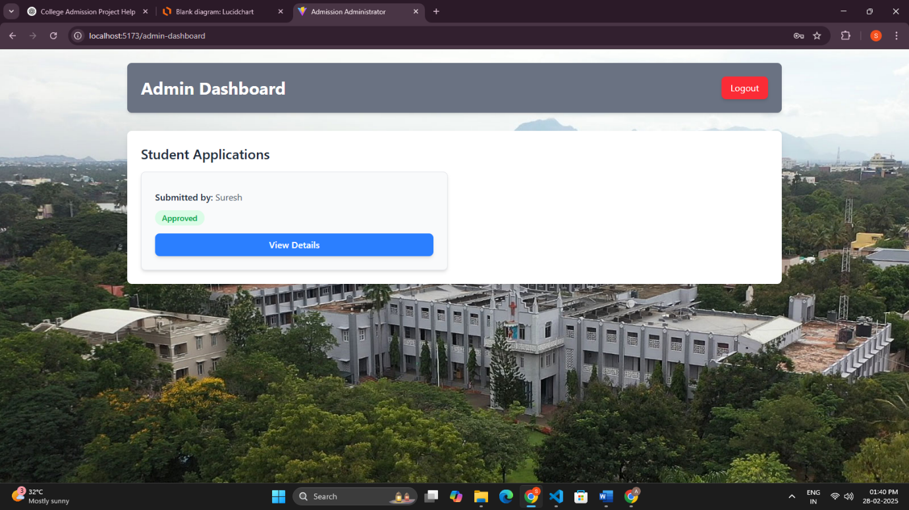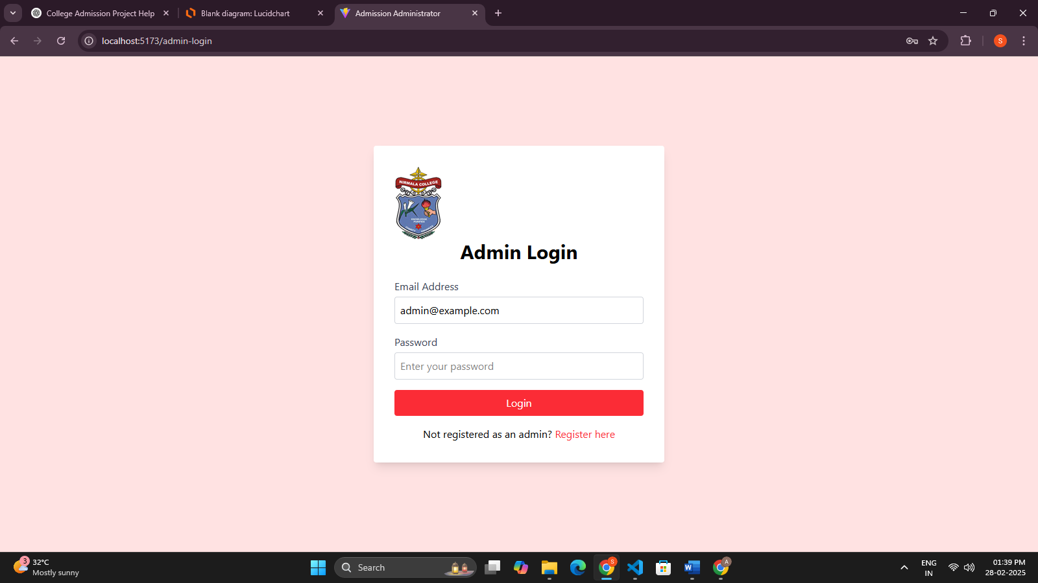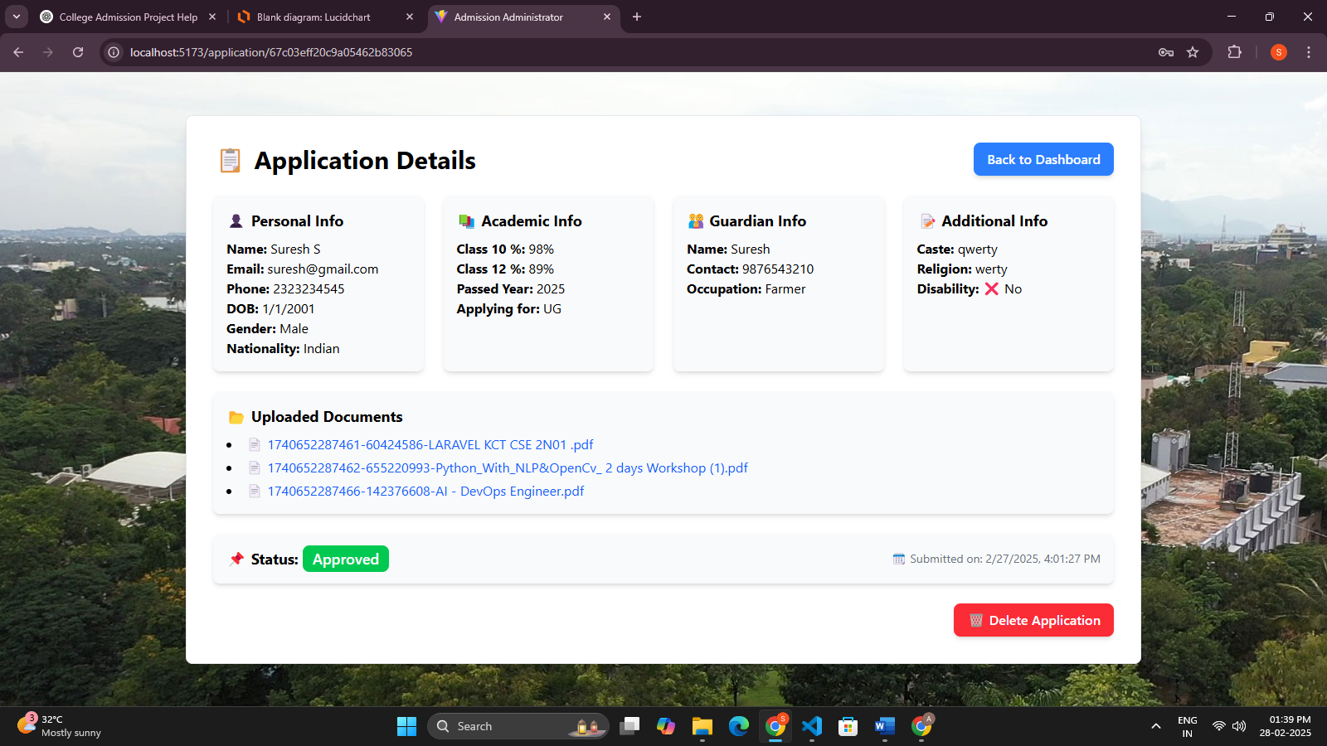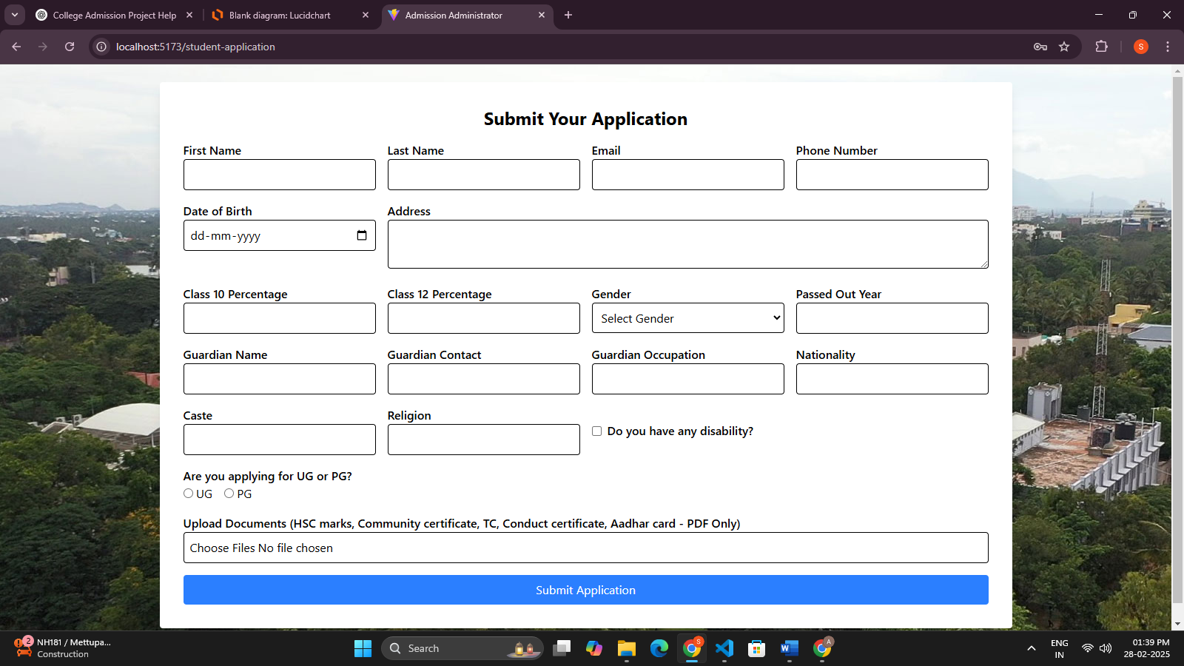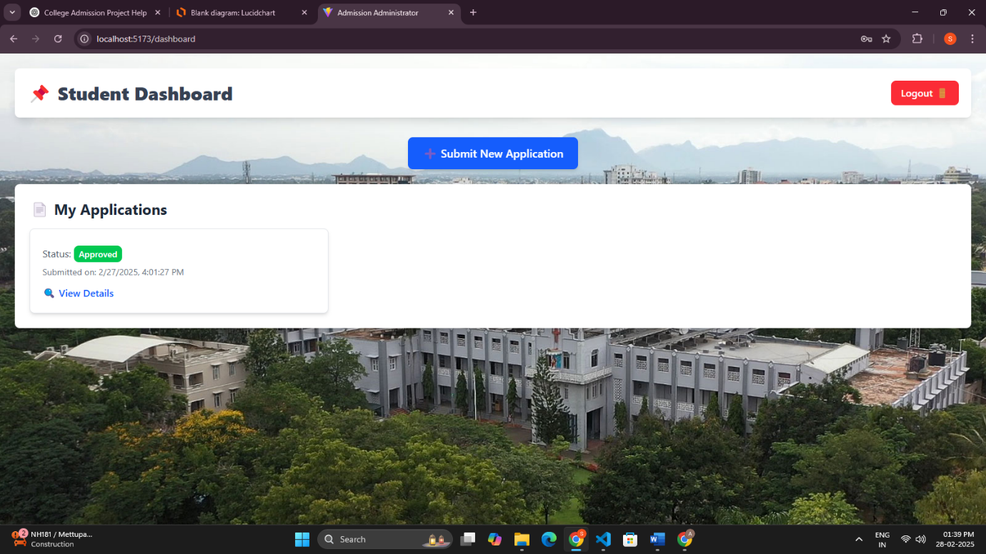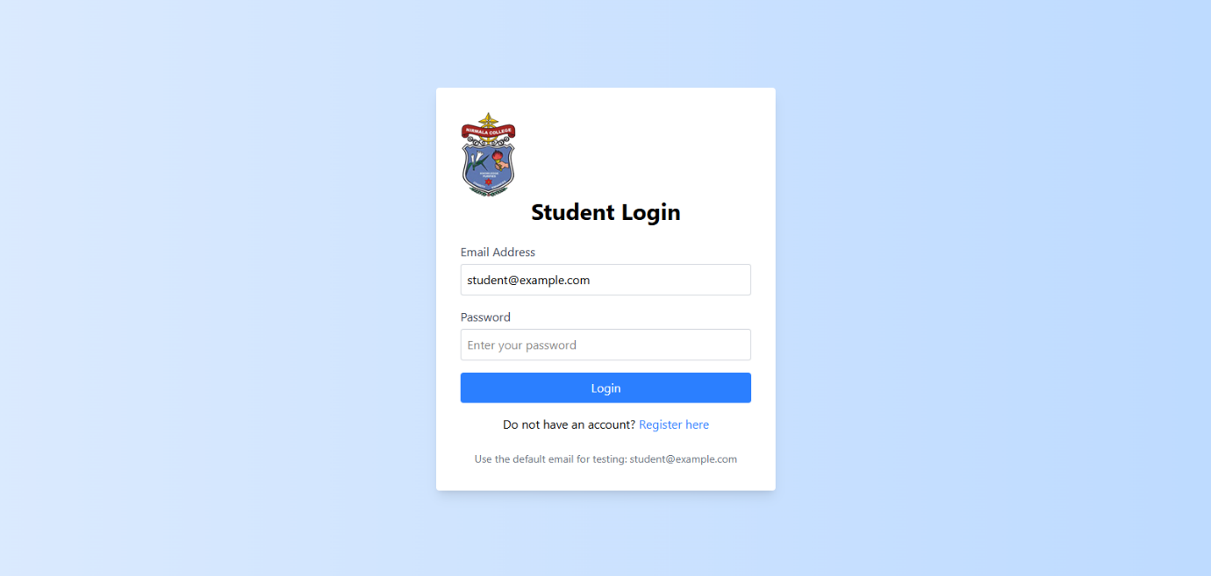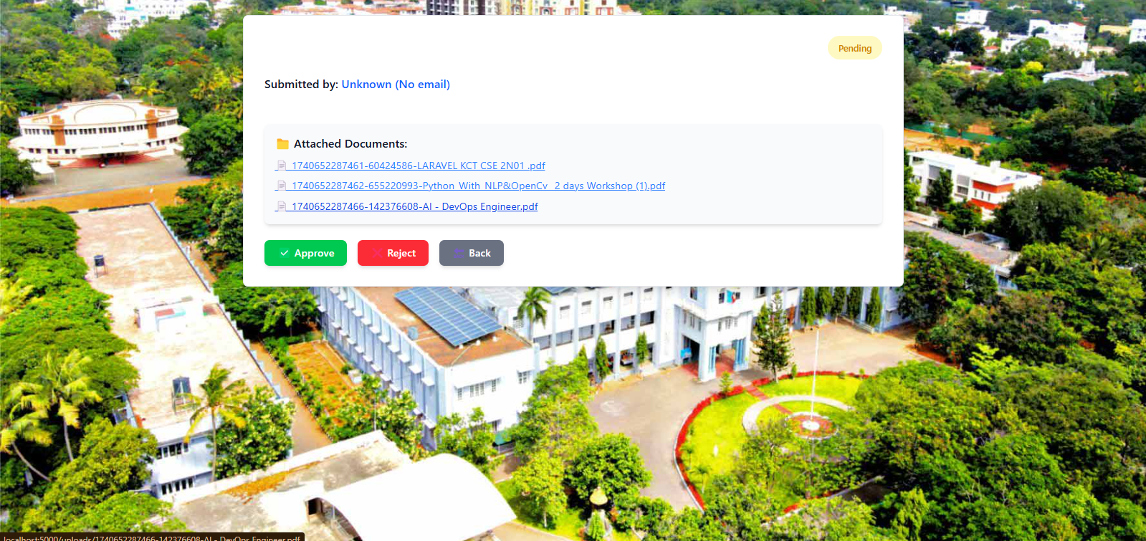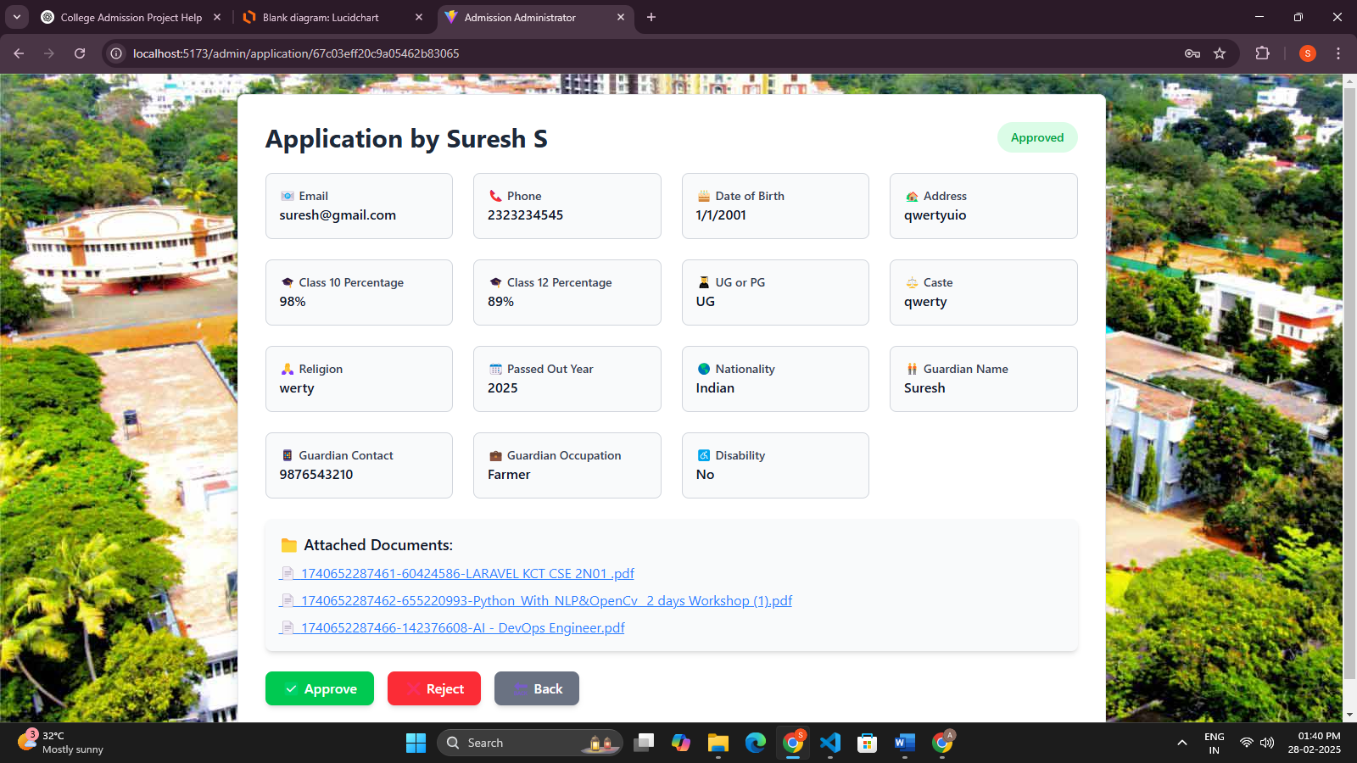

**SAMPLE CODE**

import { useEffect, useState } from "react";

import { useParams, Link, useNavigate } from "react-router-dom";

import axios from "axios";

import bg from "../assets/backgrounds/bg-img-2.jpg";

const ApplicationDetails = () => {

  const { id } = useParams();

  const navigate = useNavigate();

  const [application, setApplication] = useState(null);

  const [loading, setLoading] = useState(true);

  const token = localStorage.getItem("token");

  useEffect(() => {

    const fetchApplication = async () => {

      try {

        const res = await axios.get(`http://localhost:5000/api/application/${id}`, {

          headers: { Authorization: `Bearer ${token}` },

        });

        setApplication(res.data.application);

      } catch (error) {

        console.error("Error fetching application details:", error);

      } finally {

        setLoading(false);

      }

    };

    fetchApplication();

  }, [id, token]);

  const handleDelete = async () => {

    if (!window.confirm("Are you sure you want to delete this application?")) return;

    try {

      const res = await axios.delete(`http://localhost:5000/api/application/${id}`, {

        headers: { Authorization: `Bearer ${token}` },

      });

      if (res.data.success) {

        alert("✅ Application deleted successfully!");

        navigate("/dashboard");

      } else {

        alert("❌ Failed to delete application. Please try again.");

      }

    } catch (error) {

      console.error("Delete error:", error);

      alert("❌ Error deleting application. Please try again later.");

    }

  };

  if (loading)

    return (

      <div className="min-h-screen flex items-center justify-center text-gray-600 text-xl">

        <p>Loading application details...</p>

      </div>

    );

  if (!application)

    return (

      <div className="min-h-screen flex items-center justify-center text-red-500 text-xl">

        <p>❌ Application not found.</p>

      </div>

    );

  return (

    <div className="min-h-screen flex items-center justify-center bg-gray-100 p-6" style={{ backgroundImage: `url(${bg})` }}>

      <div className="bg-white shadow-lg rounded-lg p-8 w-full max-w-6xl border border-gray-200">

        {/* Header */}

        <div className="flex justify-between items-center mb-6">

          <h2 className="text-3xl font-bold">📋 Application Details</h2>

          <Link to="/dashboard" className="px-4 py-2 bg-blue-500 text-white font-semibold rounded-lg shadow-md hover:bg-blue-600 transition">

            Back to Dashboard

          </Link>

        </div>

        {/* Grid Layout */}

        <div className="grid grid-cols-1 sm:grid-cols-2 md:grid-cols-4 gap-6">

          {/* Personal Information */}

          <div className="bg-gray-50 p-4 rounded-lg shadow-md">

            <h3 className="font-bold text-lg mb-2">👤 Personal Info</h3>

            <p><strong>Name:</strong> {application.firstName} {application.lastName}</p>

            <p><strong>Email:</strong> {application.email}</p>

            <p><strong>Phone:</strong> {application.phone}</p>

            <p><strong>DOB:</strong> {new Date(application.dob).toLocaleDateString()}</p>

            <p><strong>Gender:</strong> {application.gender}</p>

            <p><strong>Nationality:</strong> {application.nationality}</p>

          </div>

          {/* Academic Details */}

          <div className="bg-gray-50 p-4 rounded-lg shadow-md">

            <h3 className="font-bold text-lg mb-2">📚 Academic Info</h3>

            <p><strong>Class 10 %:</strong> {application.class10Percentage}%</p>

            <p><strong>Class 12 %:</strong> {application.class12Percentage}%</p>

            <p><strong>Passed Year:</strong> {application.passedOutYear}</p>

            <p><strong>Applying for:</strong> {application.ugOrPg}</p>

          </div>

          {/* Guardian Details */}

          <div className="bg-gray-50 p-4 rounded-lg shadow-md">

            <h3 className="font-bold text-lg mb-2">👨‍👩‍👧 Guardian Info</h3>

            <p><strong>Name:</strong> {application.guardianName}</p>

            <p><strong>Contact:</strong> {application.guardianContact}</p>

            <p><strong>Occupation:</strong> {application.guardianOccupation}</p>

          </div>

          {/* Other Information */}

          <div className="bg-gray-50 p-4 rounded-lg shadow-md">

            <h3 className="font-bold text-lg mb-2">📝 Additional Info</h3>

            <p><strong>Caste:</strong> {application.caste}</p>

            <p><strong>Religion:</strong> {application.religion}</p>

            <p><strong>Disability:</strong> {application.disability ? "✅ Yes" : "❌ No"}</p>

          </div>

        </div>

        {/* Documents */}

        {application.documents && application.documents.length > 0 && (

          <div className="mt-6 bg-gray-50 p-4 rounded-lg shadow-md">

            <h3 className="font-bold text-lg mb-2">📂 Uploaded Documents</h3>

            <ul className="list-disc list-inside space-y-1">

              {application.documents.map((doc, index) => (

                <li key={index}>

                  <a href={`http://localhost:5000/uploads/${doc}`} target="_blank" rel="noopener noreferrer" className="text-blue-600 hover:underline">

                    📄 {doc}

                  </a>

                </li>

              ))}

            </ul>

          </div>

        )}

        {/* Status & Submission Date */}

        <div className="mt-6 bg-gray-50 p-4 rounded-lg shadow-md flex justify-between items-center">

          <p className="text-lg">

            <strong>📌 Status:</strong>{" "}

            <span className={`px-3 py-1 rounded-lg text-white font-medium ${application.status === "Approved" ? "bg-green-500" : application.status === "Rejected" ? "bg-red-500" : "bg-yellow-500"}`}>

              {application.status}

            </span>

          </p>

          <p className="text-gray-500 text-sm">🗓 Submitted on: {new Date(application.appliedAt).toLocaleString()}</p>

        </div>

        {/* Delete Button */}

        <div className="mt-6 flex justify-end">

          <button onClick={handleDelete} className="px-4 py-2 bg-red-500 text-white font-semibold rounded-lg shadow-md hover:bg-red-600 transition">

            🗑 Delete Application

          </button>

        </div>

      </div>

    </div>

  );

};

export default ApplicationDetails;